This assignment must be hand-written. Show ALL steps in ALL questions

Question 1  Draw the state diagram for the following circuit:  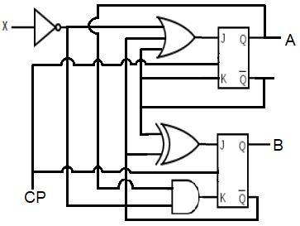 | [Ungraded - Recommended for practice]  Draw the state diagram for the following circuit:  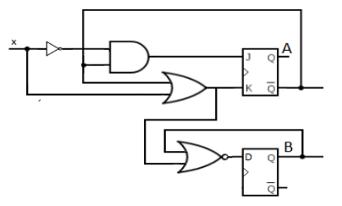
[Ungraded - Recommended for practice]  Draw the state diagram for the following circuit:  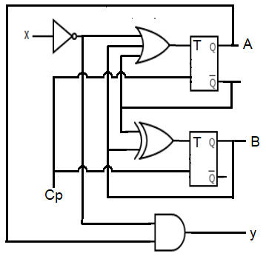 | 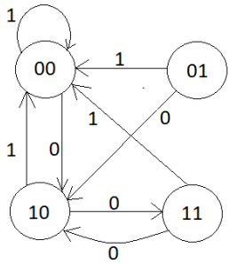  Figure: 1
Question 2:
Given the state diagram [Figure 1], get the sequential circuit using:
- SR Flip-Flop
- T Flip-Flop [Ungraded - Recommended for Practice]
Question 3:
3->5->7->11->12->14->3 Implement the given counter using:
- JK flip-flop.
- D flip-flop. [Ungraded - Recommended for Practice]
Question 4:
Implement 2 bits up/down counter using T flip flop
Question 5:
Implement the following counter using D flip flop
PHY111 - PHY112 - CSE250 - CSE251 - CSE260 - CSE340 - CSE341 - PHY111

Question 6 [Ungraded - Print and Practice]
Draw and complete the timing diagram for the following circuit, where all the flip-flops are negative-edge-triggered. Clock Pulse (CLK), TA and X waveforms are given.
